Unit Testing for BBG Outreach Email and Response

1. Below changes are implemented only for BBG (All risk Profile).

2. At Maker and RM_Vendor Worksteps a New Grid ‘Outreach Email’ will be introduced:

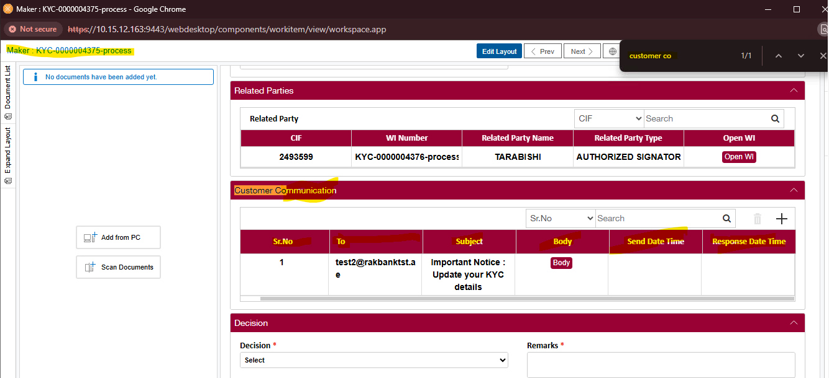

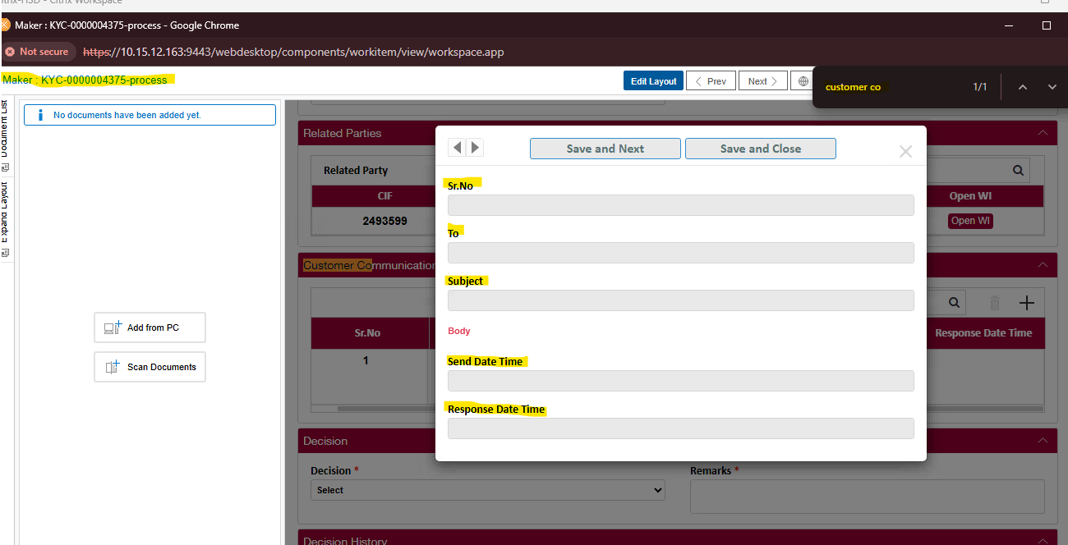

Note : The “Customer Communication” Grid is reflecting on “Maker” workstep with all its instructed Columns and properties.

Note : The “Customer Communication” Grid is reflecting on “RM_Vendor” workstep with all its instructed Columns and properties.

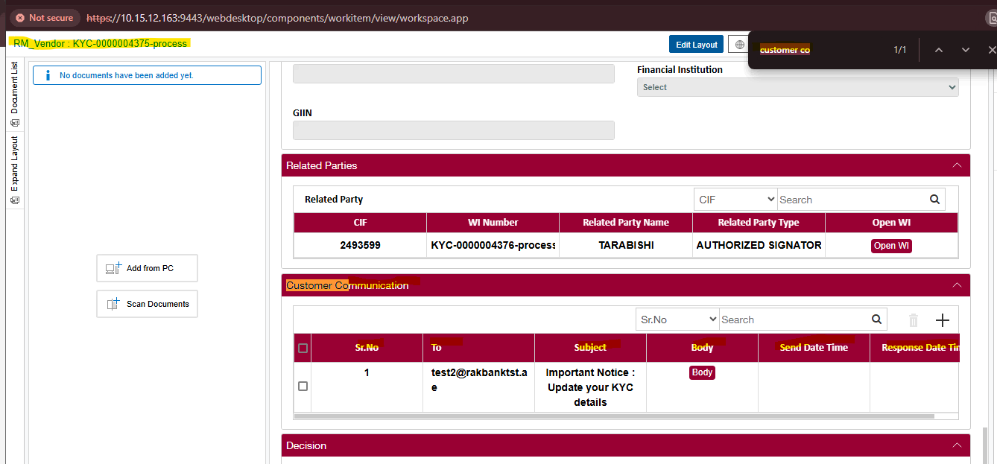

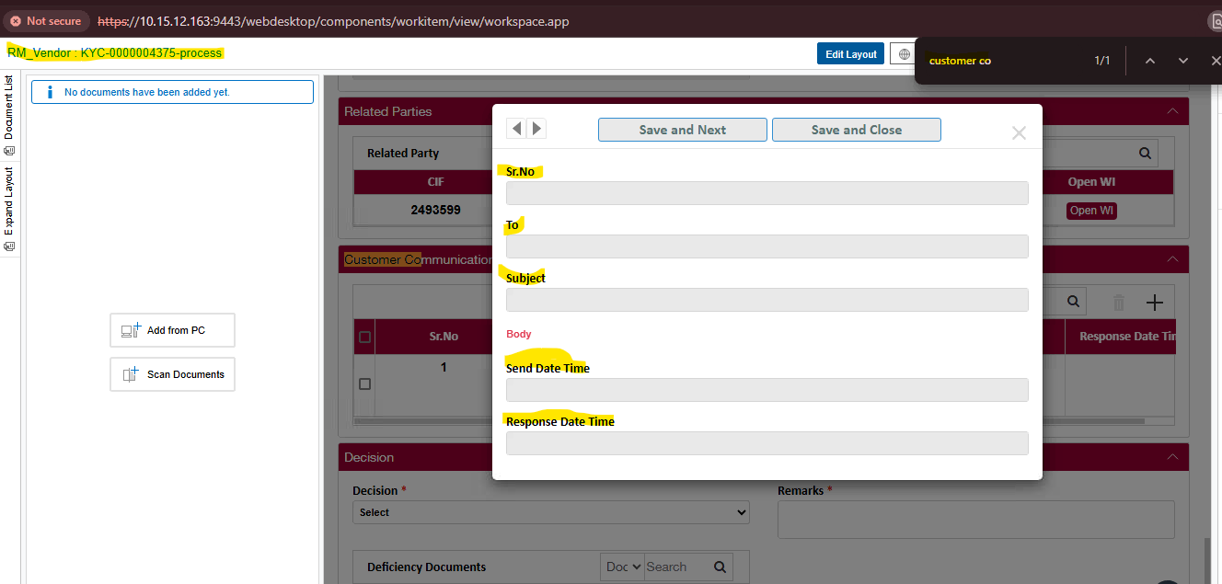

3. ‘Document for Outreach’ section will be removed from the Form for BBG WIs at Maker and RM_Vendor WS.

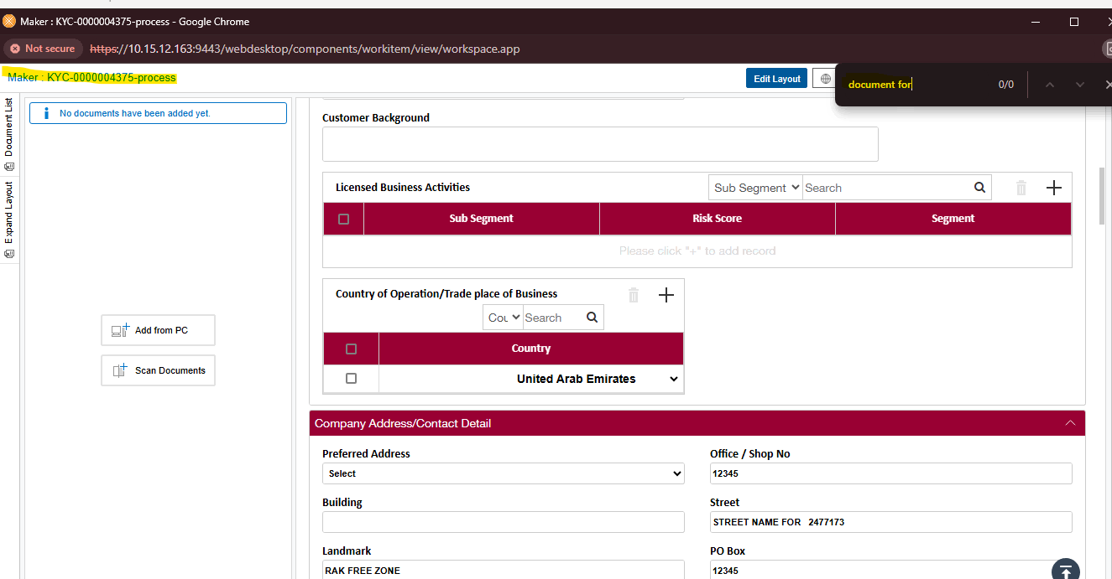

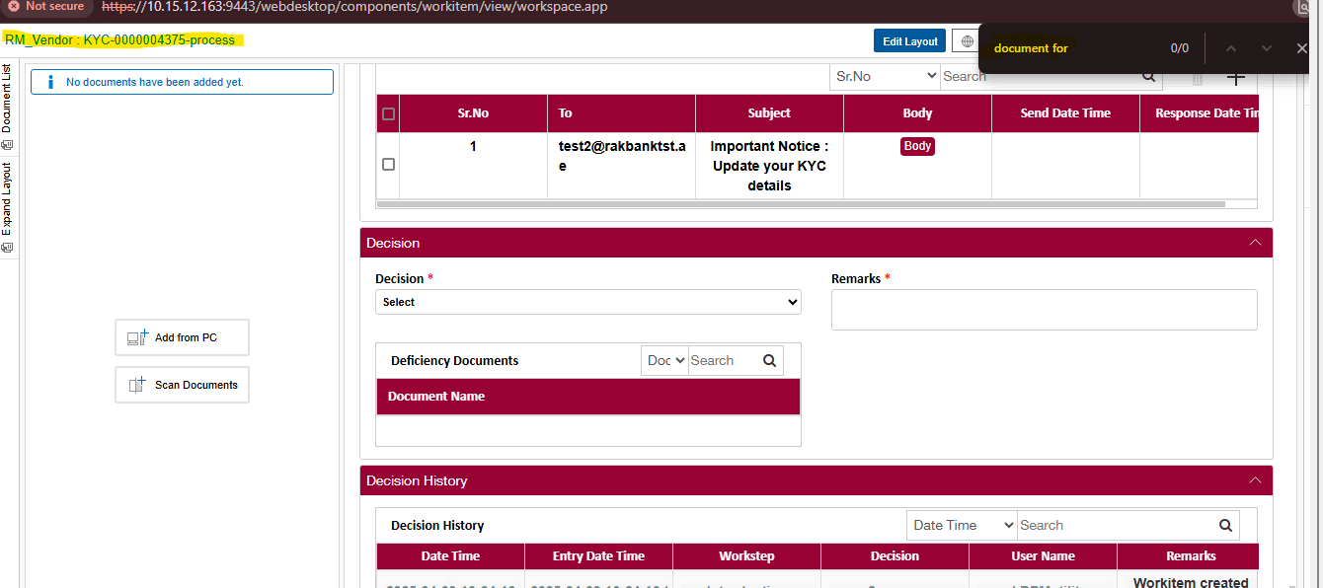

Note : The ‘Document for Outreach’ Grid has been removed from the Form for BBG WIs at Maker and RM_Vendor WS.

4. One New Decision ‘Customer Notification’ to be created at Maker and RM Vendor WS (Only Visible for BBG), this decision will be available at Maker and RM_Vendor Queue.

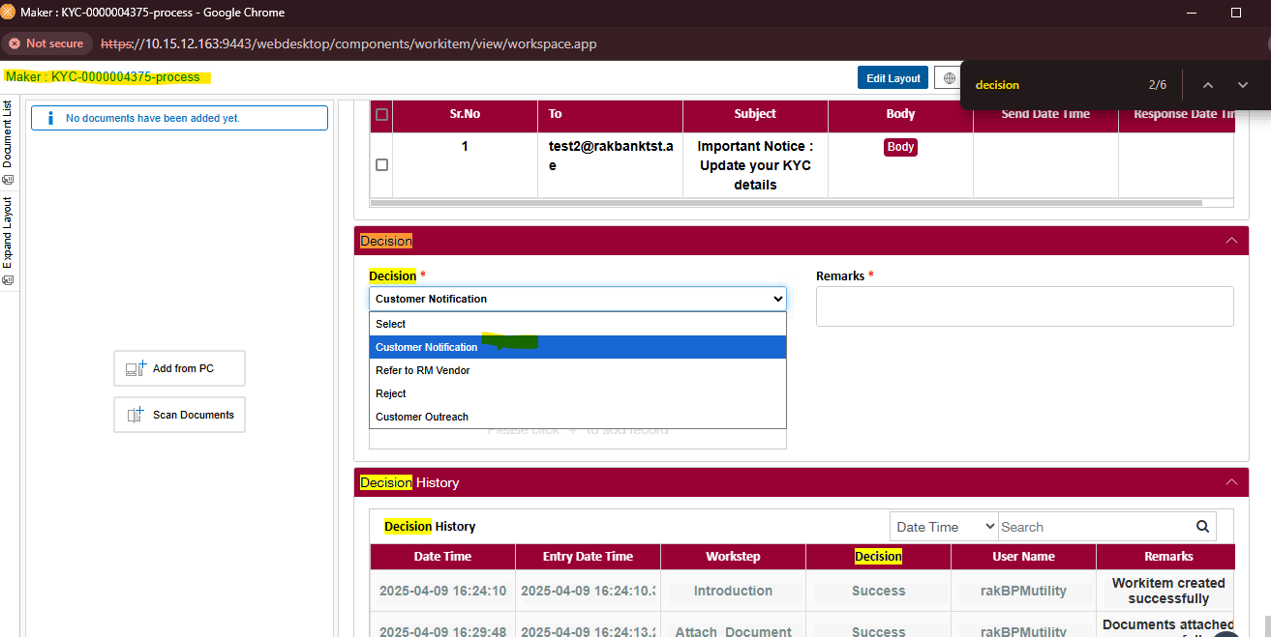

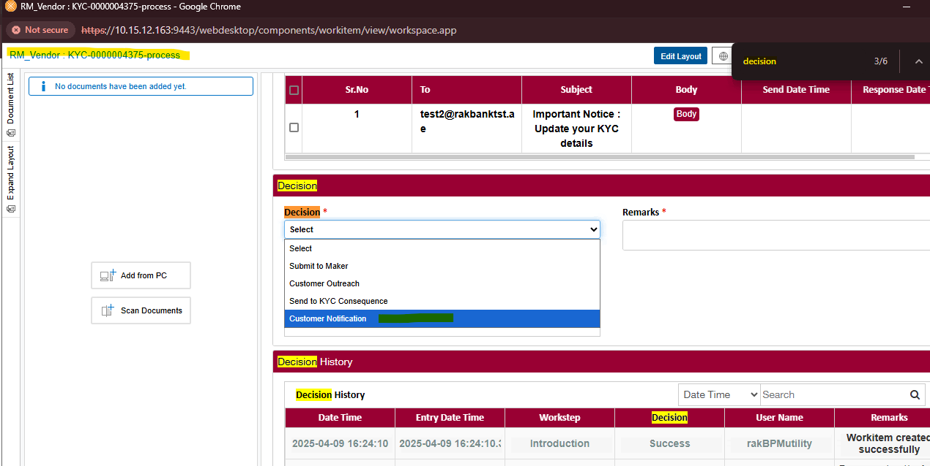

Note : Decision ‘Customer Notification’ is reflecting at Maker and RM Vendor WS.

5. If User takes ‘Customer Outreach’ or ‘Customer Notification’ Outreach email (Along with KYC form) will be automatically sent to the addresses in ‘To’ field and WI will move to a New Workstep called ‘Email Hold’.



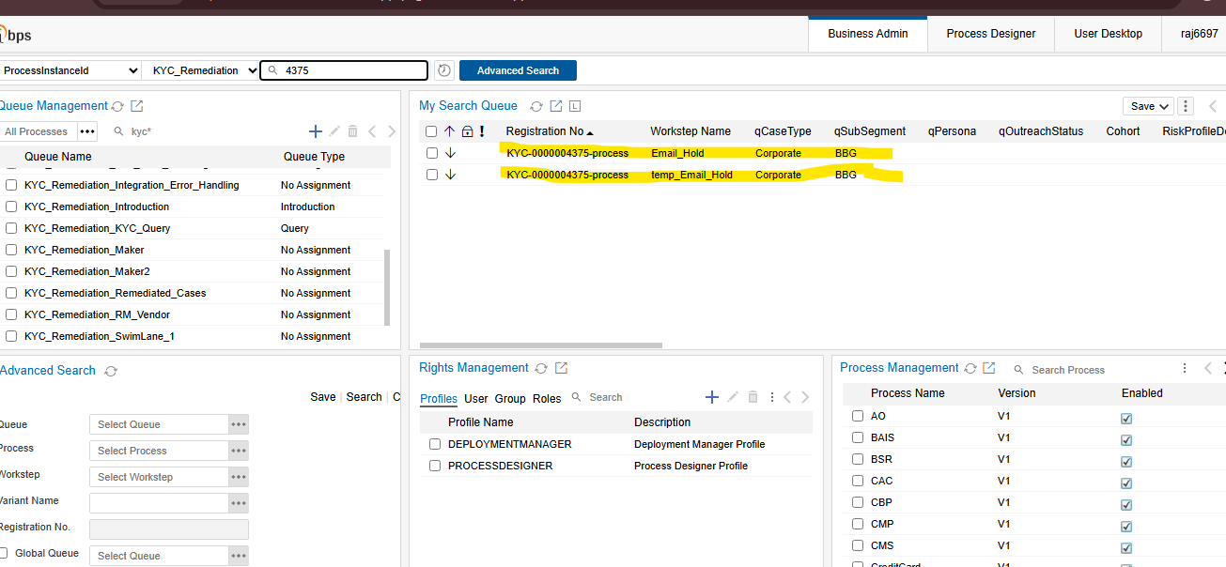Note : On Maker WS when we take decision as ‘Customer Outreach’ or ‘Customer Notification’ (Along with KYC form) will be automatically sent to the addresses in ‘To’ field and WI will move to a New Workstep called ‘Email Hold’.

7. ‘Email Hold’ WS will be User WS (the only decision available at this WS will be ‘Send to Maker 2’ and Only Action available will to Attach Documents).

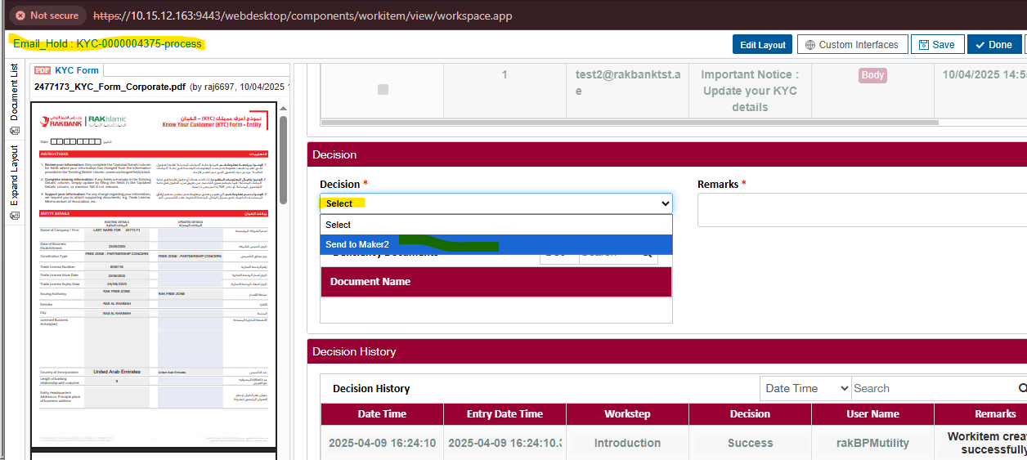Note: At ’Email Hold’ Ws there is only one decision ‘Send to Maker 2’ is reflecting.

1. At Email Hold, when the customer response comes the email and the attachments will get attached with the WI and will be moved to maker 2 Queue. Subsequent mails sent will be captured at Maker 2 and will get attached in the WI. Customet emails will be stored as 'Customer Response' and Documents will be stored as 'Previous Doc'
2. Till the time we receive customer response we will send remider mails in 15,30,45 days.
3. During this time Reminder SMS also will be sent.



11. User at Maker 2 WS can do following:

a. Download the documents and reattach to correct Doc type within the entity WI and related party WIs

b. If the user is OK with the response, user can send the WI for Further Processing

c. If the user is not OK with the response, user can send the WI back to RM_Vendor (for RM_Vendor to re-outreach)

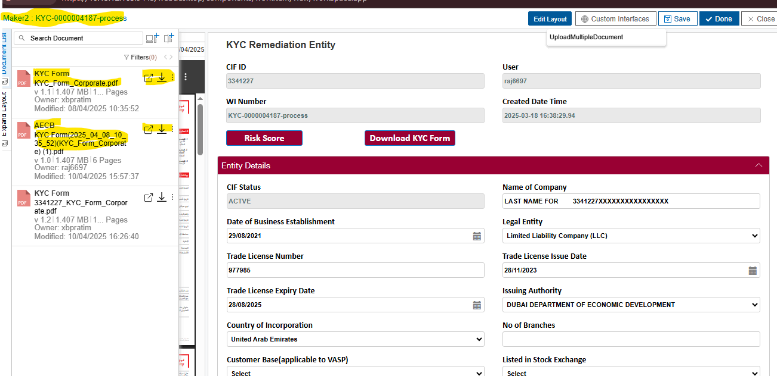

Note: Downloaded the existing document and reload the same document with another document type for entity WI.

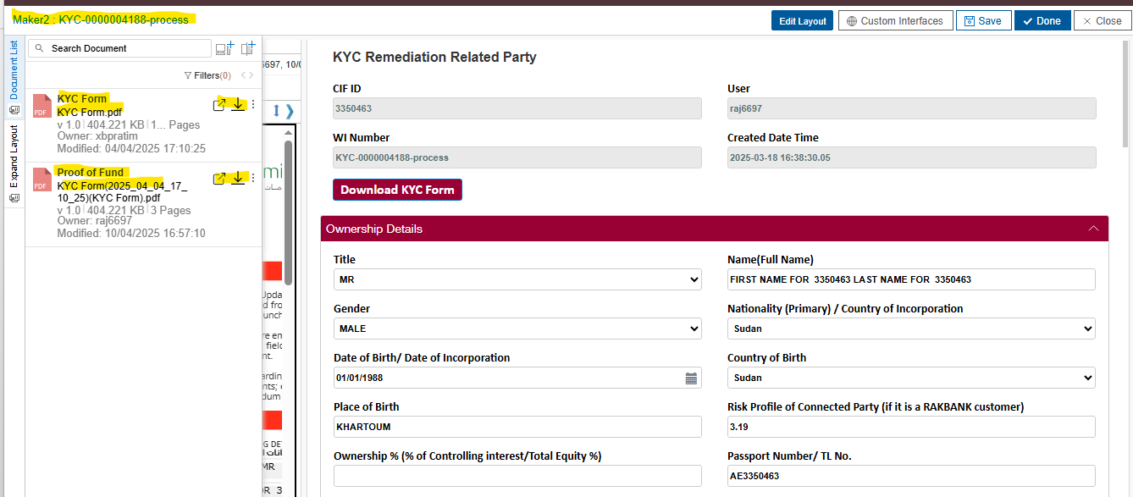Note : Downloaded the existing document and reload the same document with another document type for related party WI.

12. The user at RM_Vendor can make another Entry in the ‘Outreach Email’ grid with New Mail Body, Again the same cycle will repeat.

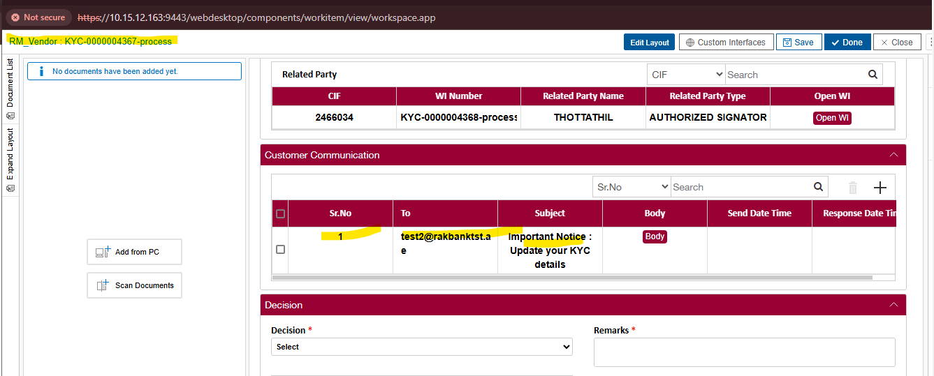Note : The user at RM_Vendor is allowed to make an another Entry in the ‘Outreach Email’ grid with New Mail Body.

13. Validations:

a. If KYC form not available for Entity WI or for any of related party, system will prompt user to generate it first.

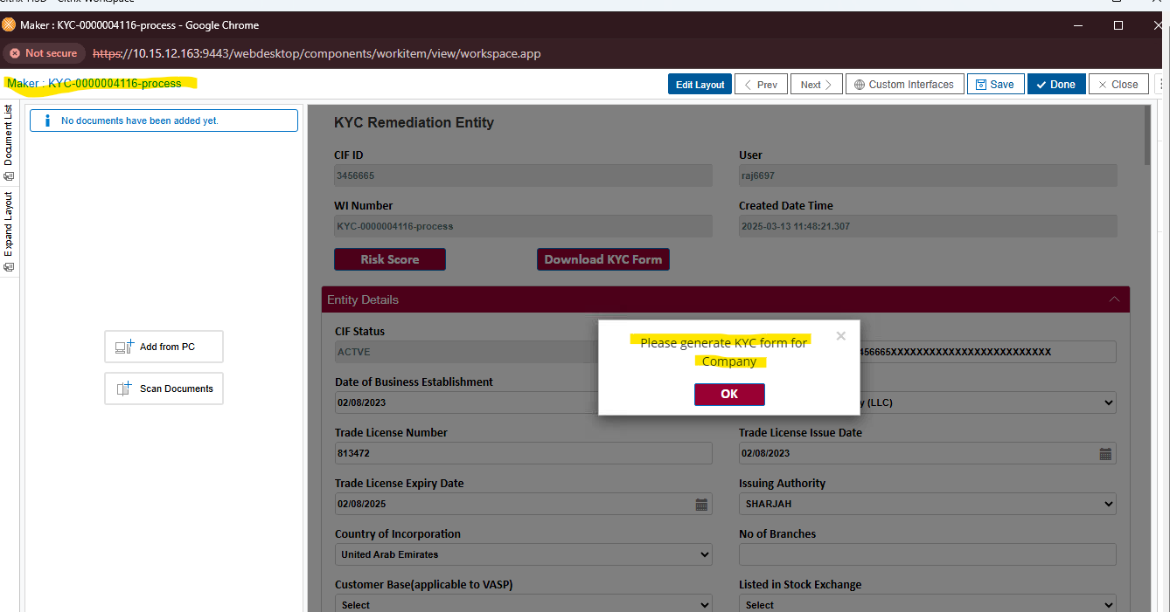

Note : The validations are like this If KYC form not available for Entity WI or for any of Related party WI, system will throw alert to the user to generate it first.